SACRED HEART CONVENT SCHOOL, SGNR CLASS – IX ENGLISH
ART INTEGRATED PROJECT WORK LESSON PLAN

AIM

Arts at the center of the curriculum, helps in clarifying
concepts. Art-integrated curriculum can provide means to bridge content of different subjects in logical, learner-centric and meaningful ways.

LEARNING OBJECTIVE
This project work aims to develop:
- Understanding of ‘Arts’ as pedagogical tool and of its impact
on the holistic learning and development of every child.
- Familiarity with art experiences (different art forms) as medium of exploring his/her creative expression.
- Skill of planning and organizing age-appropriate art
experiences to make learning of different subjects appealing.

PROCESS

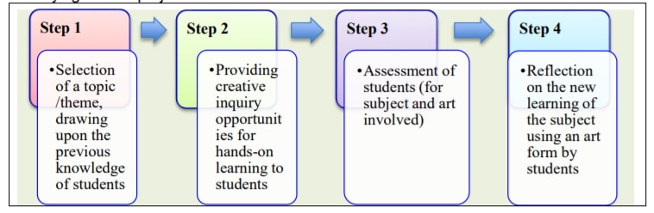

Art Material and Equipment Required
Paper and pencils, scissors, glue, chart-papers, crayons, old newspapers/magazines, sketch pens, double sided tape, cello tape etc.

LEARNING OUTCOME
Topic 1
- Understand the theme of the poem
- While creating the MIND MAP, students are able to understand the THOUGHT PROCESS of the poet.
- Students will understand personal responses in a journaling format that will have them revisit a difficult or significant choice they had to make in their life.
Topic 2
  - Understand SEMI-AUTOGRAPHICAL writing style
  - The humour element in the story, especially the dog Montumerancy.
  - The mess created by the characters Topic 3

  - Understand the concept of ADVERBS
  - Know various types of adverbs and how and when they are being used
  - Learn how adverbs modifies verbs, adjectives and adverbs

For Eg
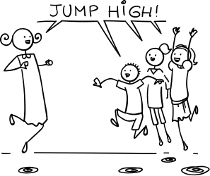
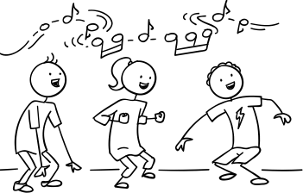
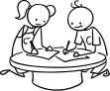
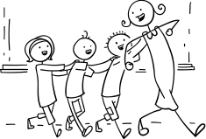

Jump High Sing Loud Read Thoroughly Play Happily

Topics
- Mind Map Presentation on the poem ‘THE ROAD NOT TAKEN’ by Robert Frost (Poem 1, Beehive)
- Picture presentation on the lesson ‘PACKING’ with a short summary. (You can re-create the textual picture presentation adding your own creativity)
- Underline the adverbs in the lesson ‘THE LOST CHILD’ (chapter1-Moments) write them onto a separate sheet. (Adverbs must be displayed under the title of the lesson) Use your imagination and creativity to display your work.

Submitted By – Mrs. Jessy James,
SHCS, Sgnr.

